

**INTERNATIONAL SCHOOL**

**GROUP PROJECT 1**

**CMU-CS 246 BIS**

**USER INTERFACE DESIGN DOCUMENT**

Version: 1.2

**CALCULATOR SYSTEM – CS**

**Mentor: Nguyen Dang Quang Huy**

***Team Member*:**

Nghia, Bui Thanh

Cuong, Vo Hung

Huy, Huynh Duc

Hieu, Tran Quang

Kien, Nguyen Trung

**Approved by Huy Nguyen Dang Quang**

**PROJECT INFORMATION**

|  |  |
| --- | --- |
| **Project Acronym** | CS |
| **Project Title** | Calculator System | | | |
| **Start Date** | 20 – Jan –2024 | **End Date** | 27 – Jan –2024 | |
| **Lead Institution** | International School, Duy Tan University | | | |
| **Team Member** | **Name** | **Email** | | **Phone** |
| 28211152203 | Bui Thanh Nghia | btn199919@gmail.com | | 0386956815 |
| 28211131430 | Vo Hung Cuong | cuong2432004@gmail.com | | 0384192943 |
| 28211103449 | Huynh Duc Huy | huynhduchuy47@gmail.com | | 0918300585 |
| 28211105375 | Tran Quang Hieu | tranquanghieunvl.2018@gmail.com | | 0799348542 |
| 28211102685 | Nguyen Trung Kien | kiennguyentrung133@gmail.com | | 0366505782 |

**PROJECT PLAN DOCUMENT**

|  |  |  |  |
| --- | --- | --- | --- |
| **Document Title** | User Interface Document | | |
| **Author(s)** | Team 2 | | |
| **Date** | Jan 24th, 2024 | **File name:** | USER-INTERFACE-DESIGN-DOCUMENT.docx |
| **URL** | https://drive.google.com/drive/u/0/folders/1nf6P2EQ6EnqGNyfGQKDEV50_6dS2TrdE?fbclid=IwAR09lzxKaZaMx0soZR6BIgPqmhSAPDv688mZVWqQBwgi4Q5-jDuyitqvtwg | | |
| **Access** | Process | | |

**SIGNATURE**

**Document Approvals:** The following signatures are required for approval of this document.

|  |  |  |  |
| --- | --- | --- | --- |
| **Mentor** | Huy, Nguyen Dang Quang | **Signature:** |  |
| **Date:** |  |
| **Project manager** | Nghia, Bui Thanh | **Signature:** |  |
| **Date:** |  |
| **Team member(s)** | Cuong, Vo Hung | **Signature:** |  |
| **Date:** |  |
| Huy, Huynh Duc | **Signature:** |  |
| **Date:** |  |
| Hieu, Tran Quang | **Signature:** |  |
| **Date:** |  |
| Kien, Nguyen Trung | **Signature:** |  |
| **Date:** |  |

**DOCUMENT HISTORY**

|  |  |  |  |
| --- | --- | --- | --- |
| **Version** | **Person** | **Date** | **Description** |
| 1.0 | Nguyen Trung Kien | Jan 25th, 2024 | Draft |
| 1.0 | Vo Hung Cuong | Jan 25th, 2024 | Draft |
| 1.1 | Vo Hung Cuong | Jan 25th, 2024 | Update |
| 1.2 | Vo Hung Cuong | Jan 30th, 2024 | Update |

**TABLE OF CONTENTS**

**I. INTRODUCTION 6**

1. PURPOSE 6

2. SCOPE 6

3. SCOPE 6

**II. LIST OF USER INTERFACE 7**

1. BUSINESS FUNCTION DIAGRAM: 7

2. MENU: 7

**III. DESCRIBE USER INTERFACE 8**

1. MENU PAGE 8

2. ADDITION PAGE 9

3. SUBTRACTION PAGE 10

4. MULTIPLICATION PAGE 11

5. DIVISION PAGE 12

6. DIVISION WITH REMAINDER PAGE 13

**TABLES**

**Table 1: List of Interface** **7**

**Table 2: Describe User Interface Menu page** **8**

**Table 3: Describe User Interface Addition page** **9**

**Table 4: Describe User Interface Subtraction page** **10**

**Table 5: Describe User Interface Multiplication page** **11**

**Table 6: Describe User Interface Division page** **12**

**Table 7: Describe User Interface Division With Remainder page** **13**

# I. INTRODUCTION

## PURPOSE

* Document the design of user interface of functions of the Calculator Management
* Be the primary document driving the implementation of the user interfaces.
* Introduce interface design for the reader. Including the background, content information display, command buttons.

## SCOPE

* This document helps to better understand the interface of the System, detailed specification components and function of the System.
* With this document, the development team can understand the structure and composition to create a consistent and complete system.
* Overview of the stages and modules of the software and create a complete interface.

## SCOPE

This document is intended for the following audiences:

* Requirements Analysts/Customers
* Project Manager
* System Designers/Architects
* Implementers, including:
  + Developers.
  + Testers.

# II. LIST OF USER INTERFACE

## 1. BUSINESS FUNCTION DIAGRAM:

*Figure 1: Business Function diagram*

## 2. MENU:

|  |  |  |
| --- | --- | --- |
| **User Interface ID** | **UI Name** | **Description** |
| UI-01 | Menu Page | Menu is used to display all system calculations |
| UI-02 | Addition Page | This page is for users to calculate the sum of 2 numbers |
| UI-03 | Subtraction Page | This page is for users to calculate the difference of 2 numbers |
| UI-04 | Multiplication Page | This page is for users to calculate the product of 2 numbers |
| UI-05 | Division Page | This page is for users to calculate the quotient of 2 numbers |
| UI-06 | Division With Remainder Page | This page is for users to to find the remainder when dividing two numbers |

*Table 1: List of Interface*

# III. DESCRIBE USER INTERFACE

## MENU PAGE

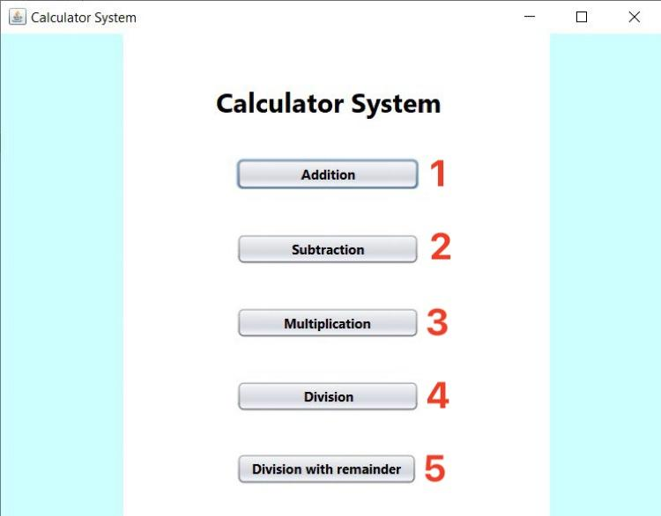

|  |  |  |  |
| --- | --- | --- | --- |
| **ID** | **Condition** | **Control Type** | **Target** |
| 1 | Press | Button | Click to move to Addition page. |
| 2 | Press | Button | Click to move to Subtraction page. |
| 3 | Press | Button | Click to move to Multiplication page. |
| 4 | Press | Button | Click to move to Division page. |
| 5 | Press | Button | Click to move to Division with remainder page. |

*Table 2: Describe User Interface Menu page*

## ADDITION PAGE

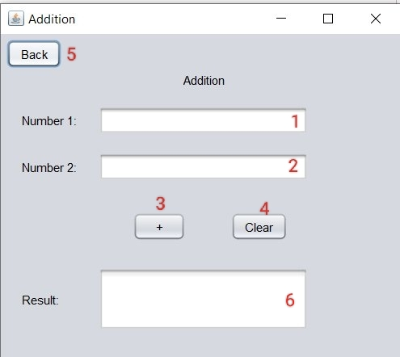

|  |  |  |  |
| --- | --- | --- | --- |
| **ID** | **Condition** | **Control Type** | **Target** |
| 1 | Press | Input number | Enter the first number. |
| 2 | Press | Input number | Enter the second number. |
| 3 | Press | Button | Click to plus 2 numbers. |
| 4 | Press | Button | Click to clear all data. |
| 5 | Press | Button | Click to back to Menu page. |
| 6 | Calculate | Display result | Print out the result of addition. |

*Table 3: Describe User Interface Addition page*

## SUBTRACTION PAGE

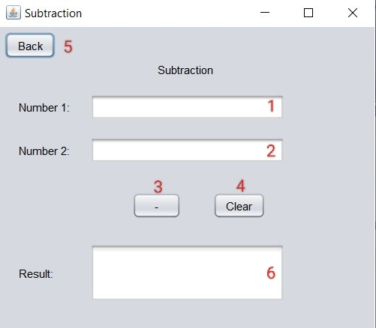

|  |  |  |  |
| --- | --- | --- | --- |
| **ID** | **Condition** | **Control Type** | **Target** |
| 1 | Press | Input number | Enter the first number. |
| 2 | Press | Input number | Enter the second number. |
| 3 | Press | Button | Click to subtract 2 numbers. |
| 4 | Press | Button | Click to clear all data. |
| 5 | Press | Button | Click to back to Menu page. |
| 6 | Calculate | Display result | Print out the result of subtraction. |

*Table 4: Describe User Interface Subtraction page*

## MULTIPLICATION PAGE

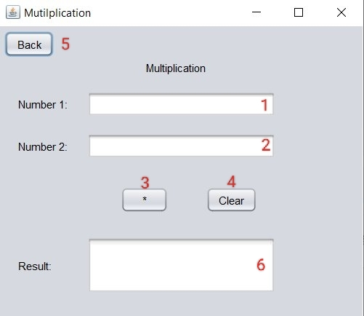

|  |  |  |  |
| --- | --- | --- | --- |
| **ID** | **Condition** | **Control Type** | **Target** |
| 1 | Press | Input number | Enter the first number. |
| 2 | Press | Input number | Enter the second number. |
| 3 | Press | Button | Click to multiply 2 numbers. |
| 4 | Press | Button | Click to clear all data. |
| 5 | Press | Button | Click to back to Menu page. |
| 6 | Calculate | Display result | Print out the result of multiplication. |

*Table 5: Describe User Interface Multiplication page*

## DIVISION PAGE

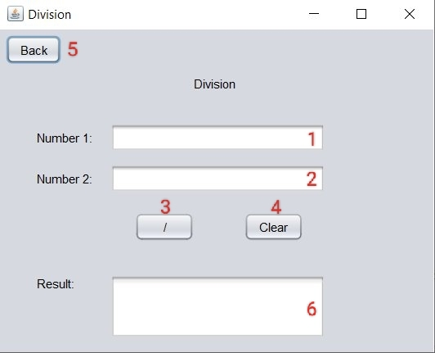

|  |  |  |  |
| --- | --- | --- | --- |
| **ID** | **Condition** | **Control Type** | **Target** |
| 1 | Press | Input number | Enter the first number. |
| 2 | Press | Input number | Enter the second number. |
| 3 | Press | Button | Click to divide 2 numbers. |
| 4 | Press | Button | Click to clear all data. |
| 5 | Press | Button | Click to back to Menu page. |
| 6 | Calculate | Display result | Print out the result of division. |

*Table 6: Describe User Interface Divison page*

## DIVISION WITH REMAINDER PAGE

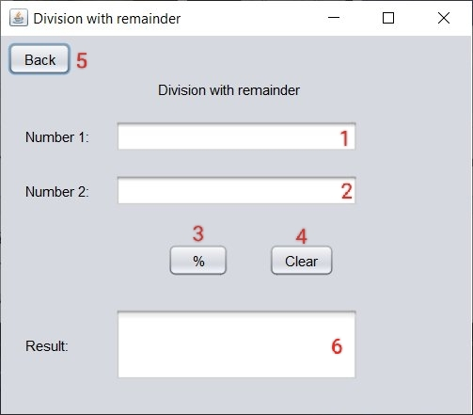

|  |  |  |  |
| --- | --- | --- | --- |
| **ID** | **Condition** | **Control Type** | **Target** |
| 1 | Press | Input number | Enter the first number. |
| 2 | Press | Input number | Enter the second number. |
| 3 | Press | Button | Click to divide with remainder 2 numbers. |
| 4 | Press | Button | Click to clear all data. |
| 5 | Press | Button | Click to back to Menu page. |
| 6 | Calculate | Display result | Print out the result of division with remainder. |

*Table 7: Describe User Interface Division With Remainder page*